# **ONLINE LEARNING PLATFORM**

# **ABSTRACT**

Online-learning fulfils the thirst of knowledge and offers online content that can be delivered for the learner at anywhere, anytime and any age through a wide range of online-learning solution while compared with traditional learning system. It also provides the rapid access to specific knowledge and information. With the rapid growth of voluminous information sources and the time constraint the learning methodology has changed. Learners obtain knowledge through online-Learning systems rather than manually teaching and learning. In this research paper proposes the online-learning management system with web services oriented frame work and SOA.This system supports the cross browser and fully integrated with different databases.This system focused around the several features namely Content Management, Content Protection, Learning Management, Delivery Management, Evaluation management, Access Control, etc., and mainly focused on integrated platform needed for online-learning and managements.

**INTRODUCTION**

The Online Learning platform encompasses the registration of students, capturing their details in the system, and facilitating automated course billing and assessments. The software assigns a unique ID to each student and automatically records both student and staff details. Additionally, it incorporates a search feature to check the current status of enrolled courses. Users can search for course availability and access student information using their respective IDs. Access to the Online Learning platform requires a username and password, accessible to administrators or instructors who are authorized to input data into the system. The stored data is easily retrievable, and the user interface is designed to be user-friendly. Personal data is securely protected, ensuring swift data processing. This system is robust, adaptable, and user-friendly, crafted to deliver tangible benefits to educational institutions. The Online Learning Management System caters to various courses, covering a broad spectrum of academic administration and management processes. It is an integrated solution that provides comprehensive information to facilitate effective decision-making for student learning, academic administration, and financial accounting seamlessly. The system is a suite of software products aimed at enhancing the quality and management of educational processes, including course analysis and activity-based costing. By using the Online Learning platform, organizations can enhance their efficiency and the quality of education delivery. Efficiently managing key processes is crucial for the success of educational institutions, and this system aids in streamlining those processes.

**PROBLEM STATEMENT**

The current landscape of traditional education systems is marked by various inefficiencies and challenges, necessitating the development of an Online Learning Platform (OLP). Traditional methods involve time-consuming processes such as manual enrollment, in-person scheduling, and physical attendance, leading to inconvenience for both students and instructors. Additionally, the lack of real-time access to course materials, limited interaction opportunities, and the absence of a centralized platform for collaborative learning hinder the overall effectiveness of the educational experience.

Furthermore, the recent surge in the demand for remote and flexible learning options highlights the need for an adaptable online learning solution. Existing platforms may not adequately address the diverse needs of learners and educators, including seamless course management, interactive engagement features, and comprehensive assessment tools. The absence of a centralized system for streamlined communication, data management, and performance tracking poses a significant challenge to the efficient functioning of educational institutions.

In light of these issues, the Online Learning Platform project aims to create a robust and user-friendly digital infrastructure that addresses the shortcomings of traditional education systems. The envisioned platform should provide a seamless, accessible, and interactive online learning experience, catering to the evolving needs of students and instructors in today's dynamic educational landscape.

**BENIFITS FOR IMPLEMENTING ONLINE LEARNING PLATFORM:**

1. Self-paced learning allows flexibility

2. Teaches learners time management skills

3. Shows self-motivation

4. Improves communication and collaboration

5. Helps people develop a global perspective

6. Builds critical thinking skills

7. Guides technical skill development

8. Lowers costs

9. Provides access to resources and creative learning opportunities

10. It’s convenient

**REQUIREMENT SPECIFICATION**

**HARDWARE REQUIREMENTS FOR PRESENT PROJECT:**

PROCESSOR : Intel dual Core ,i3

RAM : 1 GB HARD DISK : 80 GB

**SOFTWARE REQUIREMENTS FOR PRESENT PROJECT:**

OPERATING SYSTEM : Windows 7/ XP/8

FRONT END : HTML, CSS, JAVA SCRIPT.

DATABASE : MySQL

**SCHEMA**

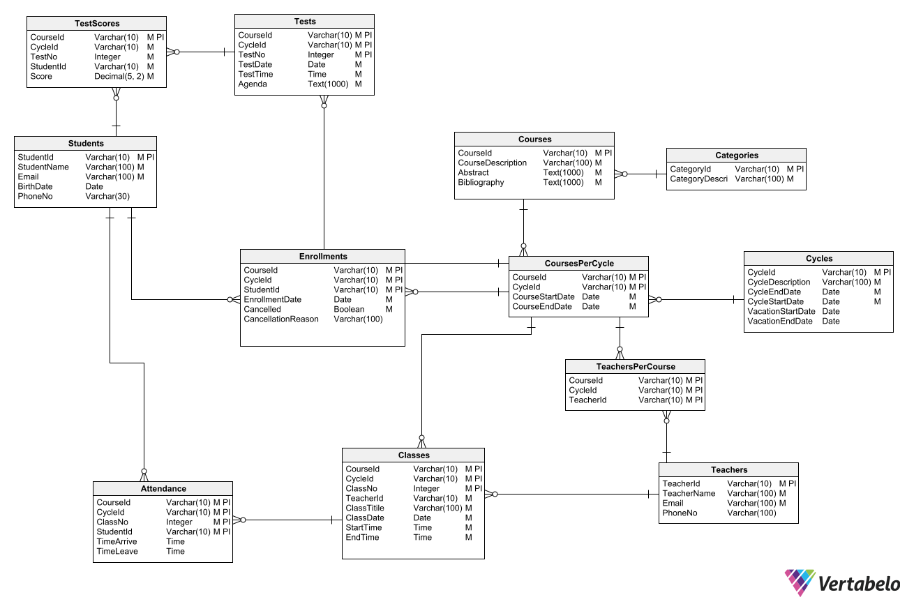

**SAMPLE OUTPUT**



